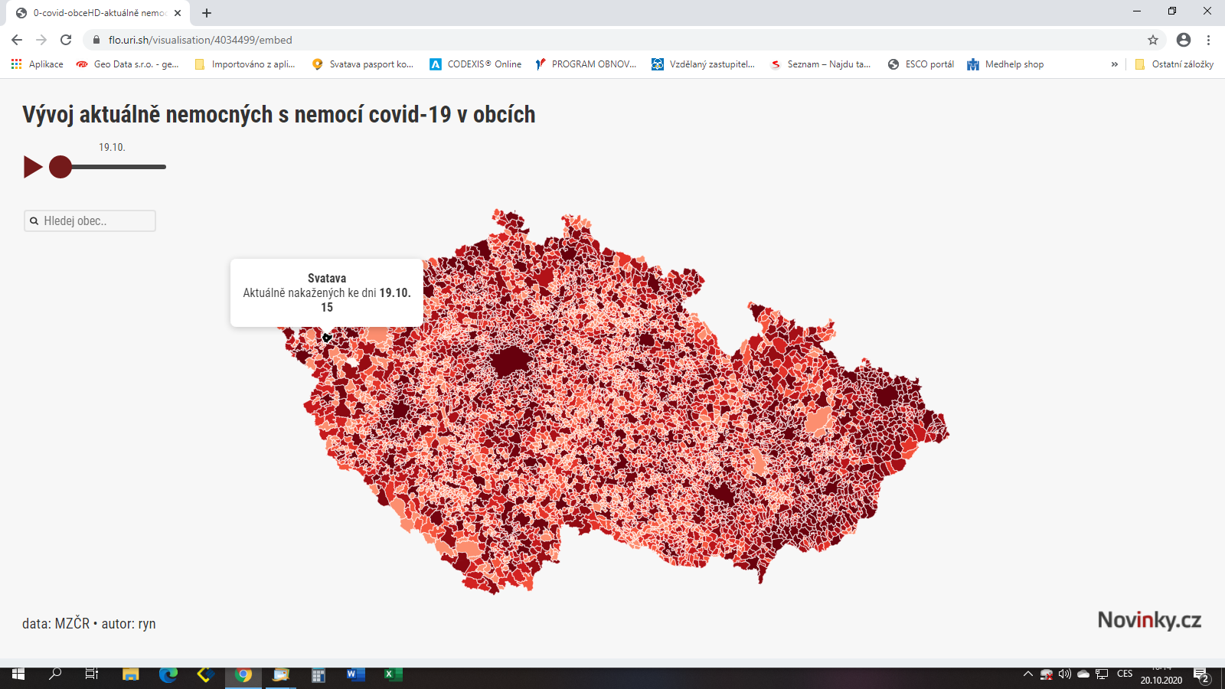
https://flo.uri.sh/visualisation/4034499/embed

